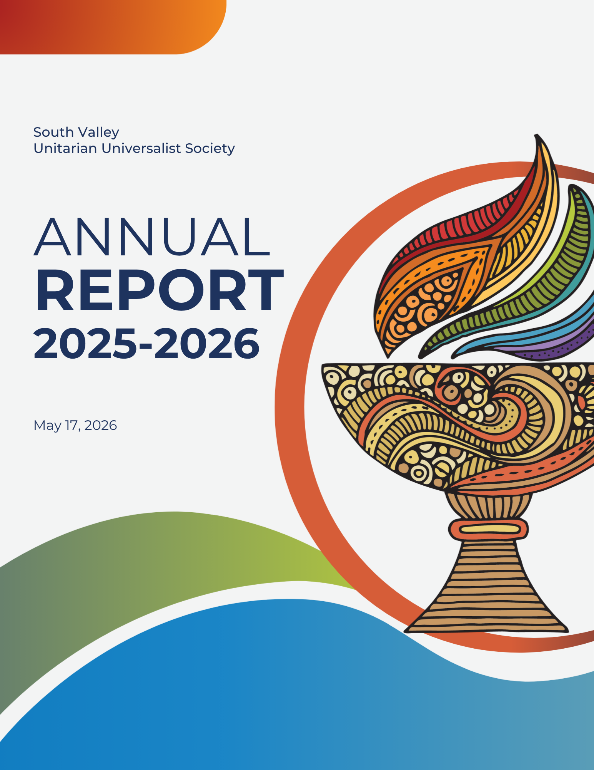

Table of Contents
SVUUS MEETING RULES OF ORDER 5
DEFINITIONS 5
MEETING RULES (SUGGESTED) 5
STANDARD “ROBERTS RULES” PROCEDURES 6
ANNUAL CONGREGATIONAL MEETING 2024-25 - MINUTES 7
LETTER FROM THE BOARD PRESIDENT 10
CANDIDATES: BOARD OF TRUSTEES & ELECTED COMMITTEES 11
STATEMENT OF FINANCIAL POSITION 12
PROPOSED BUDGET 2026-2027 13
Building Management 15
Zen Buddhist Meditation Group 15
Covenant of UU Pagans (CUUPS) 15
Endowment Committee 15
Hospitality 16
Humanists of South Valley 16
Library Committee – Connie Gates Memorial Library 17
Membership Committee 17
Operation Curb Appeal / Grounds Redevelopment 17
Prayer Shawl Ministry 18
Religious exploration 18
Religious Transitions Group 19
Safety & Security 19
Social Action Council 20
Solar Power 20
Soul Matters Small Sharing Groups 20
SOUTH VALLEY CORRIDOR MINISTRY 21
URBAN FOREST 21
Website – svuus.org 22
Welcoming Team 22
Women’s Group 22

ANNUAL CONGREGATIONAL MEETING 2025-26 AGENDA

Meeting Date: Sunday, May 17, 2026
Location: South Valley Sanctuary, 12:15 PM
Called by: Bryan Debbink, Board President
Marci Woodward, Vice President; Lauren Anderson, Secretary;
Tom Omer, Treasurer;
Members-at-Large: George Melling, Jai Hogue, & Caitlin Collins
Minister: Rev. Lora Young
Parliamentarian: Paul Barron
Leadership Team Chair: Kristen May

Topics for Discussion | Led By | Time | Purpose
Welcome | Bryan Debbink | 10 mins. | Affirm mission and year in review
Opening words and chalice lighting | Bryan Debbink | 5 mins. | Center in the warmth of love and community
Review and acceptance of meeting rules | Paul Barron | 10 mins. | Share the rules of the meeting
Establish a quorum | Paul Barron | 5 mins. | Per the SVUUS bylaws, 20% of the total membership is needed to conduct business
Approval of minutes from the last congregational meeting | Bryan Debbink | 5 mins. | Remind us of what we accomplished last year
Safety & Security Update | Bob Scarborough, Mac Lund, & Sara Quintero | 15 mins. | Update on security upgrades and efforts with Q&A
Outgoing leaders | Kristen May | 15 mins. | Recognition of service
Vote for new leaders | Kristen May | 15 min. | Per SV bylaws, leaders for Board, Endowment, and Leadership Development are elected for 3-year terms
Presentation of the proposed budget | Tom Omer | 30 mins. | Determine what is possible for us to do this next year with our pledges and other income
Vote to pass 2026-27 budget | Paul Barron | 5 mins. | Congregation votes on the annual budget each year – it is created by us, for us
Closing words and extinguishing the chalice | Rev. Lora Young | 5 mins. | Close our time together.

SVUUS MEETING RULES OF ORDER

DEFINITIONS
- The Board of Trustees schedules Community Discussion Meetings to cover community discussions of a designated topic. The Board appoints the chair/moderator. These meetings are intended to establish a consensus and/or gather ideas, congregational sentiment, etc. The meeting results guide the Board in its decision-making and in preparing proposals for action at congregational business meetings. Both members and friends of South Valley UU Society may participate. Straw polls, if used, are not binding or official. They merely indicate the views of those at the meeting. It is suggested that comments be given in the “I think/it seems to me” format, with consideration to others’ feelings and with a willingness to maintain an open mind. The purpose of the meeting and the simple ground rules of courtesy, brevity, etc. should be reviewed at the start of every community meeting.
- The Board calls Official Congregational Business Meetings/Annual Meetings for the purpose of reviewing and approving budgets, electing officers, calling ministers, bylaws changes, etc. The call to meetings and business meetings shall follow the Society’s bylaws, Robert’s Rules of Order as the parliamentary authority, and suggested meeting rules. At the beginning of each meeting, it is strongly recommended that the meeting rules, as suggested below, be presented for adoption at all official business meetings of the Society.

MEETING RULES (SUGGESTED)
The proposed meeting rules will be presented at the opening of each business meeting for adoption by the delegates. A two-thirds vote is required for their adoption; the same vote – two-thirds – is required to amend or rescind a rule. Any standing rule (except one prescribing the parliamentary authority and those that are bylaw provisions) may be suspended for a particular specified purpose by a majority vote, even if the rule requires a two-thirds vote to adopt. The purposes of these rules are to expedite business in a clear and orderly fashion, to give all members an opportunity to be heard, and to protect the rights of the minority.
Representation
- Each individual who shall speak shall be a member or friend of the Society.
- Each member shall cast no more than one vote on an issue.
- The meeting shall be open to all members and friends of South Valley UU Society, but only members shall be entitled to vote and offer motions, legislative items, and resolutions.
Debate
- Any member desiring to speak to the question under discussion shall stand (if physically able). When recognized, they shall speak into a microphone (provided) to allow all attendees to hear. Speakers shall first identify themselves and state their membership status.
- No one shall speak for longer than 2 minutes at a time without the unanimous consent of the convention.
- Debate shall follow a pro/con format until all viewpoints are heard. At that time, more points on any side may be heard.
- No one shall be allowed to speak a second time on the same question as long as any person who has not spoken to that question desires the floor. This rule does not apply to the committee chair making a report or a speaker presenting a subject/issue.
- No one shall speak more than twice on the same question.

STANDARD “ROBERTS RULES” PROCEDURES
  - Call the Question. This is used to end the debate and call for an immediate vote on the motion. It requires a second and a simple majority vote. There is no discussion on a call for “Question.”
  - Point of Order. To be directed to the chair. Point of Order is used to inquire if the Meeting Rules are being followed.
  - Point of Information. To be used for clarification or questions on the motion. A Point of Information should not be used as a method to enter into a discussion.
  - Question or Point of Privilege. This takes precedence over all other motions except three: Recess, Adjourn, and Fix the Time to Adjourn. It cannot interrupt voting or the verification of a vote. It does not require a second, cannot be amended, and is not debatable. It is ruled upon by the chair.
  - Friendly Amendment. Although not supported by Robert’s Rules, South Valley has a history of allowing Friendly Amendments from the floor. After recognition by the chair, the member offers a friendly amendment, which is typically only a minor change to the existing motion. The maker of the original motion and the seconder must agree for the amendment to the motion to take place.

South Valley Mission
“We are a community of hope for religious explorers who wish to transform our world into a more just, compassionate, and sustainable place. We embrace diversity and provide opportunities for creativity, spiritual growth, and celebration of life.”

ANNUAL CONGREGATIONAL MEETING 2024-25 MINUTES

Meeting Date: Sunday, May 18, 2025
Location: South Valley Sanctuary, 12:00 PM
Called by: Brenda Voisard, Board President
Sinnamon Wolfe, Vice President; Tom Omer, Secretary;
Bryan Debbink, Treasurer; and George Melling, Member-at-Large
Minister: Rev. Lora Young
Parliamentarian: Paul Barron
Leadership Team Chair: Kirsten May

Topics for Discussion | Led By | Time | Notes
Welcome & Covenant | Brenda Voisard | 12:05 | Brenda gave a summary of last year’s minutes, and a review of important events over the last year such as the FEMA grant, big event, pledge drive, facility use, etc.  She also reviewed the board’s goals for the year and the progress we’ve made toward them.
Opening words and chalice lighting | Rev. Lora Young | 12:12
Review and acceptance of meeting rules | Paul Barron | 12:12 | Rules as stated in the annual report have been adopted by verbal vote of congregation
Establish a quorum for 138 members | Paul Barron |  | Attendance: 73 members present - 54 needed to approve endowment proposal (see attendance rolls appended below)
Approval of minutes from last congregational meeting | Brenda Voisard | 12:15 | The minutes from last year’s congregational meeting have been accepted unanimously by verbal vote.
Being an Activist Congregation | Rev. Lora Young | 12:16 | What does it mean to be an activist? And how do we participate?  Activism is part of our theology: kindness and compassion are integral.  Why do we show up for justice? (responses from congregation)  help build the kingdom  Stop the bullies  redemption  salvation  morality / character  compassion  What approaches to justice have you seen? (responses from congregation)  Welcoming words; BLM flag; actively welcoming all  We have success when the opportunities are doable, rather than a big commitment  Four types of activism engagement styles  advocates  helpers  organizers  rebels  How is the prayer shawl ministry activism? Important skills are being taught and learned.  Hospitality has improved since we talked about it at the congregational meeting last year.  Which role are you naturally drawn to? Which one scares you or intimidates you?  (self-contemplation, then share with a neighbor)  Report out:  Some folks feel like we’re not participating in rallies as much as in the past; maybe due to communication style changes (Facebook group instead of email)  We can lift up the helpers - the less visible activism  I consider myself a rebel; I absolutely need the support of everyone else.  I was an anti-Vietnam War activist. “We ended the war.” Now I feel sad that rights are being eroded. It’s overwhelming. But it feels good to be in a room with like-minded people.  An enormous number of people are living on the economic margins now. They may be frightened to speak up; we need to help them.  Paul has helped to write inclusive policy for the court system - an example of being an advocate.  Question for us to think about while Rev Lora is on sabbatical: What is the next work for this congregation? What are the next steps?
Outgoing leaders | Kristen May | 12:43 | Those coming forward and being recognized as outgoing leaders: Maria A and Lorri Q (Lorri representing Phil);  Kristen M, Shawnee, and Jordan Roberts;  Brenda V and Sinnamon W.
Proposed amendment to bylaw | Brenda Voisard | 12:47 | Bylaw change for board membership timing:  Mac’s motion to cut off debate passed verbally with no objection.  Bylaw change passed verbally without objection.  Full text of bylaws changes  Previously reads: “Nominees shall be members of the Society for at least six months prior to the Annual Congregational Business Meeting.”  Approved Change: “Nominees shall be members of the Society for at least six months prior to the beginning of their term of service.”  Previously reads: "Members of the Board of Trustees shall be members of this Society for at least six months prior to election and shall be at least 18 years of age."  Approved Change: "Members of the Board of Trustees shall be members of this Society for at least six months prior to the beginning of their term of service and shall be at least 18 years of age.”
Voting for new leaders | Natalie Cole | 12:51 | New board members introduced: Marci, Caitlin, Lauren, and Jai.  No new nominations from the floor.  Approved by unanimous vote; no objections.  Jordan Roberts was introduced as nominee for another term on the endowment committee. No other nominations from the floor. Jordan was approved unanimously by the congregation.  Kristi Jensen was introduced as the nominee for the leadership succession committee. No new nominations from the floor. Approved by unanimous vote with no objections.
CUUrb Appeal | Collin Surles | 12:59 | Collin gave recognition to all those who have helped develop CUUrb Appeal over the last 6 months.  Collin walked through the details of “our new front yard.”  The city negotiations are still ongoing around the storm drain. That’s the biggest unknown. The north side courtyard is the thing that will either happen or not based mostly on the storm drain outcome.  Questions from the floor:  Maintenance - What’s the impact and have we planned for it?  We anticipate that adjustment to the maintenance fee should be minimal
Endowment distribution proposal | Sinnamon Wolfe | 1:14 | Proposal from endowment committee and board of trustees for disbursing $110k from the endowment fund.  Questions from floor:  What is the endowment fund? Paul gave an overview of the history.  Current total value: $699k. Most of which is invested with a UUA administered fund.  What loans have been made to the congregation and are still outstanding?  $52k is still outstanding to be paid back to the fund  With this dispersal, will the fund continue to meet its goal of being a reserve for the future?  Paul: yes  What obligations does the fund need to cover?  Paul: none. We don’t owe anyone anything  I’ve never seen such a large disbursement, but I think it’s a good investment because of what it will do for the congregation.  Sinnamon: This is a different way to invest in our community  Vote: required 51. Counted 58 yes votes by the raise of hands. The fund disbursement passes.
Presentation of the proposed budget | Bryan Debbink | 1:27 | The finance committee has lots of work, and we could use more volunteers. As one example, Pete B is working to improve our auditing processes.  Notable numbers from Bryan’s presentation:  $1M+ total assets  $194k cash position (much of which is obligated due to ongoing efforts like CUUrb Appeal)  $224k+ pledged for the coming year drive (a record high 80+ pledge units)  $313 proposed deficit for next year’s budget (basically $0)
Voting to pass 2025-26 budget | Paul Barron | 1:45 | Some people have left, so there was another count of the members to make sure we have a quorum: yes we still have enough.  Questions on budget from congregation before the vote:  Do we anticipate any huge expenses in the upcoming years?  nothing other than the parts of the CUUrb Appeal project that we don't do right away.  Do we have a line item for maintenance of the new grounds?  Covered under existing line items, and we accounted for the increase.  Mac moved to cut off discussion - Approved unanimously by verbal vote.  Budget passes by verbal vote unanimously.
Closing words and extinguishing the chalice | Rev. Lora Young | 1:49 | Thank you for staying to the very end!  Rev Lora: “It is my joy and privilege to extinguish the chalice as my final act before my sabbatical begins in about 10 minutes.”

Attendance Rolls

Members

Scott Renshaw
Laura Renshaw
Marci Woodward
Nancy Melling
George Melling
Shauni Roberts
Natalie Cole
Kristen May
Bryan Debbink
Thomas Omer
Brenda Voisard
Kathleen Luck
Andera Henderson
Keith Henderson
Melissa Venable
Caitlin Collins
Lauriane Collins
Sarah Featherstone
Luci Malin
Hana Adams
TJ Adams
Peter Busche
Jessica Hercules
Collin Surles
Kristin Berg
Peter Verschoor
Kevin Alvey
Rosemary McAtee
Becky Condas
Cameron Adams
Milton Braselton
Peggy Montrone
Tucker Gurney
Ted Gurney
Alex Davis
Mac Lund
Maria Anderson
Amy Russian
Janis Ries
Louise Colfield
Lunetta Roy
Madeline Abram-Moyle
Lorri Quigley
Cortney Bouldin
James Neiswender
David Vickery
Jai Hogue
Kim Adams
Palmer Pattison
Zach Stickney
Sinnamon Wolfe
Nancie Pratt
Tammy Felt
James Felt
Sheri Lund
Paul Barron
Bill Dobbs
Lauren Anderson
Ben Granda
Kristine Jensen
Bob MacGillivray
Cate MacGillivray
Page Speiser
Bob Speiser
Charles Christansen
Maureen Davies
‘

Friends
Greg Rasmussen
Brenda Julander
Nik Gottfredson

LETTER FROM THE BOARD PRESIDENT
Dear South Valley Community,
It has been a truly remarkable year at South Valley Unitarian Universalist Society. As we reflect on our journey together, I am filled with profound gratitude for the ways YOU have moved us toward our vision of radical and liberating love. This year, our collective movement has not only deepened our internal roots but also widened our reach into the world to respond with love and spread our salvific life-affirming embrace.
Thanks to your incredible collective generosity, the stewardship of our physical home has seen extraordinary milestones. We have officially completed "Operation Curb Appeal", transforming our outdoor spaces into a beautiful, welcoming gateway for all who enter our grounds. Simultaneously, our commitment to safety has matured; the FEMA-funded security upgrades to our doors and windows are complete, and we have already submitted our application for the next round of grant funding to continue this vital work. Our Safety and Security team has also formalized a "Guardian" team and trainings, ensuring we provide a secure space for worship and community.
This year also tested and proved the strength of our lay leadership. While Rev. Lora took her well-deserved sabbatical, our congregation did not just wait—it thrived. We saw the strength of our community in action, and we are now enjoying robust and increased Sunday attendance as we gather to celebrate our shared values.
Finally, our faith is finding its voice in the wider world. We have begun taking a more active role in responding to immigration crackdowns and raids, standing in solidarity with the vulnerable. We are also exploring how to bring the "Good News of UU" to new areas, investigating outreach and services in Utah County and Southwest Salt Lake County to meet the spiritual needs of our broader region.
It has been a profound honor to serve as your Board President during this period of growth and deepened connection. This community is an active force. You and I and we create it. Together. We nurture it and grow it. Let’s make it rain and snow and make an avalanche of justice. Y’all give me the confidence that we can tackle whatever’s next.
Searching always with love,
Bryan Debbink
Bryan Debbink
Board President, SVUUS
"I will teach my boys to be dangerous men. And pick white flowers for all of their friends. And to think of patience when they think of strength. I will teach my boys to be dangerous men." - Lucas Jones

CANDIDATES: BOARD OF TRUSTEES
& ELECTED COMMITTEES
BOARD OF TRUSTEES CANDIDATE
Kristen May (she/her)
Kristen has attended South Valley for 14+ years and has been a member for 13. She has been actively involved in the religious education program, having spent many years teaching RE classes to children, junior high, and high school students. She serves on the RE Council and is certified to teach the Our Whole Lives curriculum to K–12 students, a role she has filled numerous times. Kristen loves helping make the fun happen at SVUUS. She joined the auction tech team more than a decade ago, coordinated the auction for several years, and now serves on the auction committee. She has run the Mystery Pals program since 2016 and is currently transitioning it to a team-led effort. Kristen's four children grew up at SVUUS, and she is deeply grateful for this community that offers support to people of all ages.
Our outgoing board member is George Melling, while Bryan Debbink, Tom Omer, Marci Woodward, Caitlin Collins, Lauren Anderson, and Jai Hogue will continue to serve.
ENDOWMENT COMMITTEE CANDIDATE
Laura Renshaw (she/her)
Laura and her husband, Scott, have attended South Valley for 27 years. She has worn a variety of hats here, including Director of Religious Exploration, Board President, Membership Chair, Stewardship Co-chair, and RE teacher. She is currently participating in a Soul Matters group and is a facilitator for Starting Point. She doesn't consider herself a finance person, but she's nonetheless excited about serving on this committee. Her goal in this role is to raise awareness about how the endowment fund supports our ministries. Laura is the manager of the Millcreek Library and has worked for Salt Lake County for 12 years. In her free time, she loves reading or playing board games with her family.
The outgoing member is Ann Scarborough. Continuing members are Paul Barron and Jordan Roberts.
LEADERSHIP SUCCESSION COMMITTEE CANDIDATES
Brenda Voisard (she/her)
Brenda has loved South Valley for a long time and has had the chance to learn and grow in a variety of roles through the years. She is excited about our congregation's energy and direction for our future, and about creating a space for everyone to have that growth opportunity in whatever form of leadership interests them. The deep connections we build with one another as we give our talents to this profound organization often come through the time we spend in formal and informal leadership roles. She is a retired healthcare administrator and is married to Maureen (3 times + 1 renewal of vows so far).
Ann Scarborough (she/her)
Ann has been a member since 2016 after moving to Utah from Minnesota, where she and her husband (Bob) had been active in Methodist churches for 39 years. Finding this community felt like coming home, and she has been committed to serving on the Welcome Team, the Board of Trustees (2017-2020), Soul Matters, the Safety & Security Team, the Social Action Council, and others. She loves getting to know what people are passionate about and helping them "plug in" to serving in areas that feed their souls. She sees opportunities to blend the tasks of Leadership, Succession & Development with the Welcome Team's commitment to addressing the needs of South Valley newcomers. She views faith communities like ours as great training grounds for trying new things and developing leadership skills. Ann operated a Wellness Center in MN and is a retired Massage Therapist. She and her husband are partners in Crescita Management Southwest, based in Scottsdale, AZ.
Outgoing members of the leadership succession committee are Kristen May and Kristy Jensen. Continuing member is Natalie Cole.

STATEMENT OF FINANCIAL POSITION

Comparison of April 30th Reports 2024 - 2026

 | April 2024 | April 2025 | April 2026
Total Liabilities | $6,991.99  - Accounts Payable  - $6,991.99 | $13,622.91  - Accounts Payable | $9,571.94  - Accounts Payable $8,740.77
Total Equity | $934,572.33  - Bank Accounts  $80,977.76  - UT Sales Tax Receivable  $1,472.74  - Fixed Assets  $180,474.44  - Endowment  $643,179.47 | $1,026,362.10  - Bank Accounts  $165,663.65  - UT Sales Tax Receivable  $2,525.44  - Fixed Assets  $235,745.72  - Endowment  $629,207.41 | $948,715.16  - Bank Accounts  $46,690.97  - UT Sales Tax Receivable  $3,337.43  - Fixed Assets  406,888.30  - Endowment $491,707.46
Cash On-Hand | May 18th, 2024  $56,045.31 | May 13th, 2025  $194,163.88 Total  - CUUrb Appeal  $118,000  - Unrestricted  $76,163.88 | May 16th, 2025  $46,490.97
Profit/Loss YTD, JUL-APR | $66,500.72 | $81,511.08 | $-115,352.56 (includes CUURB spending as the FEMA reimbursement was not received until May 1)

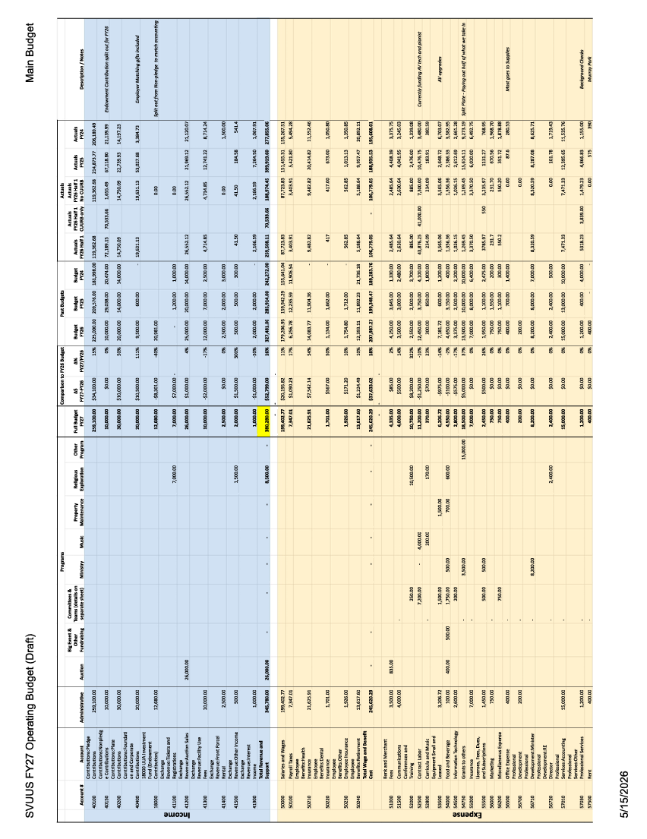
PROPOSED BUDGET 2026-2027
South Valley UUS CONFIDENTIAL Page | 14

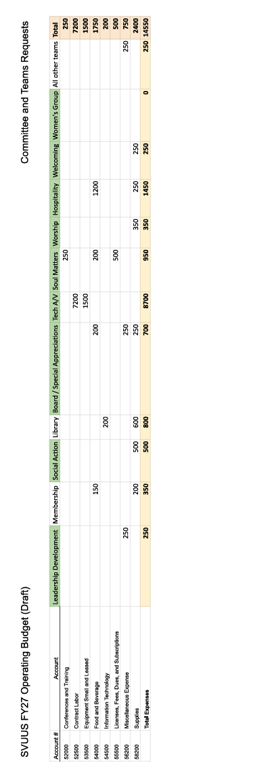
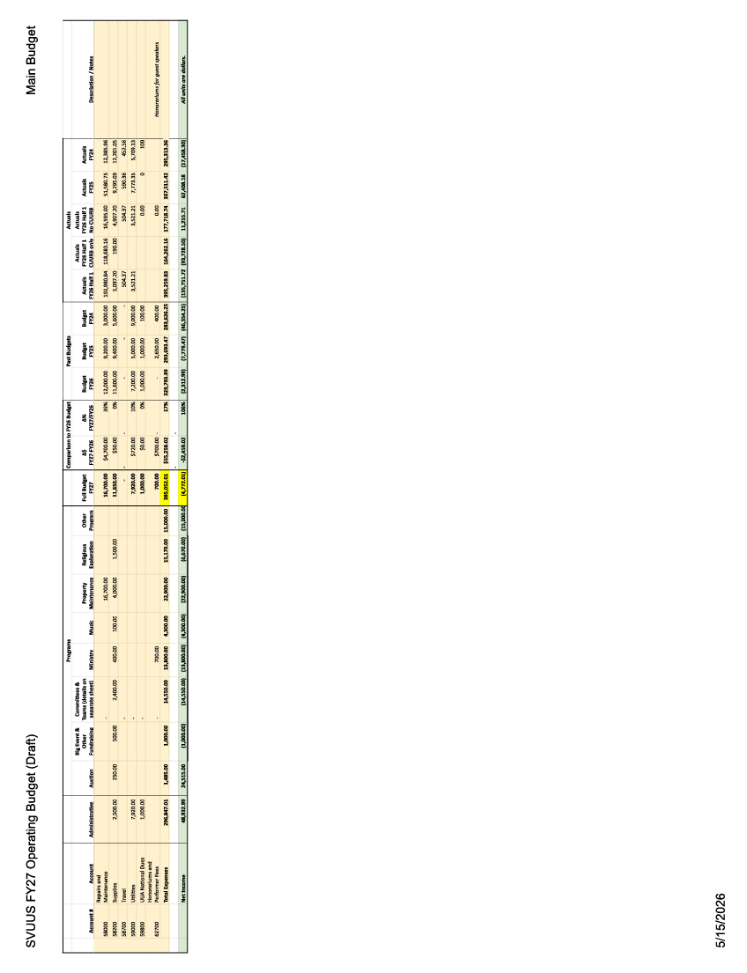
South Valley UUS CONFIDENTIAL
COMMITTEES & GROUPS

Building Management
James Carlson, Building Manager
This year, our Building Manager played a vital role in the continued care, safety, and improvement of our campus. He contributed significantly to the FEMA grant process, helping to oversee the installation of new windows, doors, and upgraded safety systems that will benefit the congregation for years to come.
He also helped direct the refresh of our grounds and worked tirelessly to rebuild different sections of our aging fencing after severe winds brought them down – twice! In addition, he is currently replacing the skirting on the annex building and continues to keep our facilities clean, well-maintained, and freshly painted, ensuring our campus always remains welcoming and beautiful.
He shares in the excitement of South Valley’s continued growth and is honored to support Rev. Lora and the mission of the congregation as the community continues to flourish.

Zen Buddhist Meditation Group
Facilitator: Bob Speiser
Our group has continued meeting weekly, with a lively 5-6 regulars, including several new people. We’ve practiced as a group for 12 years, the last eight at SVUUS. No budget needed for the very simple things we do.

Covenant of UU Pagans (CUUPS)
Chair: Kim Lane
Team: Kathleen Luck, Cathy Calara
The Earth-centered spirituality group continues to foster deep connection through nature, community, and spiritual growth. Embracing a variety of Earth-based traditions, we are proud to be part of the congregation's vibrant and inclusive community life.
Our monthly gatherings, held every 2nd Sunday, provide a welcoming and supportive space for spiritual exploration, and we are always open to new participants, both in person and virtually. We invite anyone who is curious to join us in community and celebration.

Endowment Committee
Chair: Paul Baron
Members: Ann Scarborough, Jordan Roberts, Tom Omer (Board/Treasurer), Lauren Anderson (Board of Trustees representative).
Ann’s term on the EF Committee ends on June 30, 2026. Paul’s term ends in 2027 and Jordan’s in 2028. One member is elected each year for a 3-year term, and the Board of Trustees selects two of its members to serve on the EF Committee.
The South Valley Endowment Fund was established to ensure, in perpetuity, the continuity and growth of SVUUS and the causes it supports. It is managed by the Endowment Fund Committee as described in the By-Laws. Per the By-Laws, the committee must disburse between 1.5% and 3% of the fund value annually to the congregation.
The EF Committee corresponded throughout the year to discuss business associated with the SVUUS Endowment Fund. The value of the fund as of 12/31/2025 was $633,994. This value reflects $485,716 invested in the Unitarian Universalist Association’s Common Endowment Fund (UUCEF), plus two loans to the congregation ($96,000 for security enhancements, and $52,278, which is the remaining balance of monies loaned to the congregation between 2012 and 2014).

The share value in the UUCEF Pool increased 12.5% for the 12 months ending 12/31/2025. The UUCEF follows ESG (Environmental, Social, and Governance) principles to apply UU values to fund investing. Our EF Committee recognizes that the return is below the overall market but understands the importance of investing conservatively and in line with UU values.
A disbursement of $110k was approved at the 2025 congregational meeting for parking lot and landscaping improvements. This was split and disbursed into three allotments from the UUCEF over the summer of 2025, following the principle of dollar-cost averaging to reduce the risk of a single disbursement occurring at a poor market time.
The EF Committee voted in September 2025 to disburse an additional $46k in a loan for FEMA (Federal Emergency Management Agency) security projects, in addition to the $50k previously approved in the prior fiscal year. More funds were needed to pay up-front project costs. This money will be repaid to the Endowment Fund as ARPA (American Rescue Plan Act) funds reimburse South Valley for these projects.
Our South Valley EF Committee has voted to disburse 2% of the fund value to the congregation this year, totaling $12,680, to support South Valley’s budget process for the 2026-27 church year, and to write off 1% of the fund value ($6340) from the $52,278 loan, bringing that balance down to $45,938.

Hospitality
Co-Chairs: Chris and Sarah Hansen
Committee: Maria Andersen, Brenda Voisard, Kamis Dewey, Cate MacGillivary, Marilyn Smith, Elaine Totten-Beal, Sheri & Mac Lund, Peter Vershoor, Ted & Tucker Gurney, Hana Adams,
Leo & Pallas Brandon, Jessie Petersen, Candi Anderson, Madelyn Warr, Robb Carlson,
Shauni Roberts & Parry Harrison
We have only canceled hospitality once in the last year due to a lack of volunteers. We call that a big win!
Keeping the calendar full with four volunteers every Sunday is a challenge. We have the best luck texting volunteers directly to ask them to sign up; email is less effective.
The additional sign-up for the congregation to bring snacks is not as successful as we had hoped. The intention was to involve more people; however, we aren’t getting enough support, so we often resort to serving dry goods from the cupboard. We would love to see more folks within the congregation bring in treats to share during coffee hour.

Humanists of South Valley
Committee: Ted Gurney, Tom Omer, Palmer Pattison
The Humanist Group has provided a space for thoughtful discussion, reflection, and connection centered on human experience, ethics, and inquiry. The group has also contributed to congregational life through Humanist-themed Sunday services and shared learning opportunities.
At this time, the Humanist Group is on hiatus as participants reflect on the group's future direction and discern who may feel called to help lead its next chapter. We are grateful for the many conversations, insights, and contributions the group has brought to congregational life and look forward to seeing how this ministry may evolve in the future.

Library Committee – Connie Gates Memorial Library
Chair: Denna Wright
Library Committee: Rosemary McAtee, Gloria Olsen, Lorri Quigley, Andrea Henderson, Fred Gurney, & Kathleen Luck
We just completed our best book sale ever — totaling $305. We would like to apply this amount to purchasing another computer for the library. Ours is quite old and no longer accepts updates for Windows OS or for Resource Maate, the library's management program. The cost of purchasing a new computer is around $600; both Lorri (our tech person) and Palmer have recommended it.
In addition, we request our usual amount of $350 for supplies and new books.
The library serves as a community gathering spot for newcomers to browse and chat, and kids to enjoy the play and drawing materials we put out.

Membership Committee
This year, we began the process of re-imagining our Membership Team in collaboration with leaders from across the congregation. Conversations and planning are currently underway as we explore new ways to foster connection, welcome, and belonging within our community. Meetings with key stakeholders have begun, and we look forward to sharing more updates and vision for this evolving work in the fall.
We also celebrated a joyful Membership Ceremony this year, where we officially welcomed ___ new members into our congregation. We are grateful for the energy, presence, and commitment these new members bring to our shared community.

Operation Curb Appeal / Grounds Redevelopment
Committee Chair: Collin Surles
Contributing Committee Members: Brenda Voisard, James Carlson, Mac Lund, George Melling, Nancy Melling, Bob MacGilivray, Sinnamon Wolfe, Jess Hercules, Sutton Morgan, Tasha Jenson, Kevin Alvey, Bob Scarborough, Rev. Lora, Bryan Debbink, Milt Brasselton, Lauren Anderson, Dustin Wiberg (non-member landscape architect), Jeff Hanson (SVUUS friend landscape architect)
How We Help Fulfill the Mission of South Valley: Besides the urgent need to replace our 45-year-old parking lot, the Curb Appeal project turned our unsavory and unusable grounds into a beautiful space with multiple uses—kids play, kids classes, meeting space, social gatherings, auction parties, small concerts and speakers, coffee hour, weddings, receptions and other rental usage, and hopefully—once we add the right fencing—a place for pet blessing after parties.
Fund Raising: Between our fall 2024 and fall 2025 congregational raises, private source funding, $110,000 from the South Valley Endowment Fund, and funding from George & Nancy Melling specifically for the south-side urban forest, we raised a total of $344,286.
Expenses
- Millcreek Gardens - Urban Forest - $67,000
- Miller Excavation & Paving - $89,187
- Blackbird Construction - Water Meter Move - $10,950
- Parking Lot Cutting, Cleaning, Sweeping & Stripes - $3,837
- Topwater Concrete - $28.814
- Adair Landscaping & Irrigation - $107,262
- Engineering, Surveys, City Permits, Light Pole Removal - $17,550
- Railings - $8,442
- Signage, Sidewalk Lights, Planter Pots, Misc. - $4,620
TOTAL - $337,665
Committee suggestions for next steps (priority order TBD at a later date - does NOT include future FEMA upgrades)
- Replace both north and south emergency exit stairs
- Engraved stone sign on the island by the ADA parking
- Small pavilion - likely in the very back northwest corner
- Painted mural along fenceline on west side of parking lot
- New gate for north parking entrance
- Picnic tables in grass areas - with accessible sidewalks - locations TBD once we see how the space is used
- Climbing dome for playground area

Prayer Shawl Ministry
Chair: Lorri Quigley
Committee: Kevin Alvey, Cate McGillivray, Louise Cofield, Gloria Olsen
The Prayer Shawl Circle is a small group of members and friends who come together monthly for spiritual growth and to serve members and friends of our church and occasionally the wider community. We create handmade projects to share with those who might need comfort and support from the congregation. We also made shawls or afghans for those teens bridging from RE into the young adult group.
We use the materials from the Soul Matters small group ministry program to guide our discussions. We have a short meditation, help each other with our projects, and have a group discussion – all the while creating beauty and comfort through the work of our hands. Then we continue to work on our projects independently at home.
The prayer shawls are a physical reminder of our connectedness and that we are part of an interdependent web. Completed projects are provided to the minister and the Caring Circle to determine who might need comfort.
Challenges:
We would love to have more members join our group. Newcomers are welcome even if you are just beginning to learn how to knit or crochet. All of us who are participating have found this group to be a positive experience. The members of the group donate their time and all materials for the projects and no church funds are provided.

Religious exploration
Susan Bowman, DRE
I’m so grateful to have joined you as Director of Religious Education this past December. In these first few months, I’ve had the joy of getting to know many of our children, youth, and families, and of beginning to build meaningful experiences together. None of this has happened alone - so much of what we’ve been able to offer has come through the care, creativity, and generosity of a growing circle of volunteers who continue to step forward with enthusiasm and heart.
During the holiday season, we gathered for an all-ages outing to Light Up Main Street in Midvale, which was a wonderful opportunity to connect and celebrate together outside of Sunday mornings. We also shared a special moment during a December worship service, when our children offered a performance that brought warmth and joy to the whole congregation.
Together, we’ve launched OWL (Our Whole Lives) for our 7th–9th graders, creating a thoughtful and supportive space for our youth to explore identity, relationships, and values. We’ve also revived the Coming-of-Age program, walking alongside our young people as they reflect on their beliefs and their place within this community.

One of the things I’ve especially loved is helping to start a monthly children’s chapel, which we lead with the support of volunteers. In that time, we share meditation, stories, discussion, movement, and creative activities - offering a space where our children can explore spirituality in ways that are engaging and grounded. Starting in the Fall, we will increase this program to twice a month.
We’ve also been building community through events like the RE kickoff and the start of Mystery Pals, as well as engaging our children in the annual Easter tradition, “Hunt for Justice,” inviting them to connect more deeply with our shared values through action and curiosity.
I want to take a moment to express deep gratitude for our interim DRE, Cameron Adams, whose dedication and care helped revive and re-energize this program. Cameron’s work in rebuilding connections, promoting participation, and laying a strong, thoughtful foundation has made it possible for me to step in and continue growing from a place of strength. I am truly thankful for all that was given during that time.
As we look ahead, I feel both excited and hopeful about what we can continue to grow together. My hope is that our religious education programs will continue to become more inclusive, connected, and rooted in our shared commitment to compassion and justice. I’m especially excited to continue building relationships with our children and youth, with families, and with all of you, and to nurture a program where everyone feels a sense of belonging.

Religious Transitions Group
Lead: William T. Dobbs
The Religious Transition Group (RTG) was founded in 2003 to provide support and community for individuals navigating changes in their religious identity and spiritual journey. Over the years, the group offered a compassionate and confidential space where participants could openly discuss the challenges that often accompany religious transition, including family expectations, shifting beliefs, questions of meaning and identity, and the complexities of maintaining relationships across differing faith perspectives.
Grounded in shared values of kindness, honesty, confidentiality, mutual support, respectful dialogue, and “conversation, not conversion,” RTG created a space where people could feel seen, heard, and accepted during times of significant personal change. The group affirmed the dignity of religious freedom and supported participants without judgment, wherever their journeys led.
After many years of dedicated leadership and care, Bill has retired from facilitating the group. At this time, the Religious Transition Group is on hiatus until someone feels called to carry the ministry forward. We remain deeply grateful for the meaningful support RTG has provided to so many members of our community over the past two decades and for the compassion and commitment Bill brought to this important work.

Safety & Security
Lead: George Melling
Team: Ann and Bob Scarborough, Dave Eliasen, James Carlson, Janis Ries, Mac Lund, and Palmer Pattison
In January 2025, after much hard work by Bob Scarborough, Mac Lund, and James Carlson, South Valley received a $150,000 grant from the Federal Emergency Management Agency (FEMA) to upgrade our facilities to better protect against threats of violence. The windows in the church have been improved with a protective film, designed to stop small-caliber bullets. Our front doors have been replaced with new, more secure doors with controlled locks. Additional security cameras have been installed, and certain members are serving as guardians to monitor for suspicious persons during worship services.
David McKean, a retired FBI agent and employee of the Security Community Network, which provides security for the Jewish community, led several training sessions on Safety and Security Preparedness.
Mac Lund led fire drill sessions and "stop the bleed" training.
The initial expenditures were funded by the Endowment Committee, which was reimbursed upon receipt of the FEMA grant, after verification that the funds were spent appropriately.
The team has now applied for a second FEMA grant to further upgrade South Valley's security.

Social Action Council
Co-Chairs: Cameron Adams, Zach Stickney
Committee: Alyssa Johanson, Cameron Adams, Kimberly Adams, Krista Bowers, Natalie Cole, Susan Eyzaguirre, Zach Stickney, Jessica Hercules, Kathleen Luck
The Social Action Council helps UU members live our values in the world beyond our doors. We help organize community service, protest, and civic engagement/activism activities, and work to establish relationships with groups and organizations that share our values. We also work together to determine the monthly recipients of our split plate offering for our religious services.
We continue to work to develop intergenerational activities for the congregation and hope to create more opportunities for volunteer service and action in our community.

Solar Power
Tucker Gurney (tuckerted@comcast.net)
We have continued to get excellent power generation from our 75 solar panels since their installation in early 2014. Each year, our solar array has generated about 31 megawatt hours of power.
The initial cost of $69,700 was covered by a large grant from Rocky Mountain Power, a small grant from Utah Power & Light, and $4,000 of our own money. There have been no additional costs in the past 12 years, just huge savings (about $4000 per year) on our electrical bills!
However, our solar data has been unavailable for four months now. The electricity is flowing as it should, but we don’t have a record of it from the solar system. The “gateway”, a device that collects data from the microinverter under each solar panel and transmits the data to the internet, is old and struggling. A new gateway costs about $700. Every year, I have requested that $500 be included in our annual budget to cover possible repairs. This will be our first need for that line item.
I hope a new gateway will be ordered soon. Meanwhile, you can see photos of the installation and old power output graphs at the “Energy Stats” section of our website at <www.svuus.org/whatwebelieve/socialaction/>. (Look in the menu on the right under “Get Involved” and then on the left in “Social Action” and scroll down.)
I am also old and struggling. Being the solar system manager just consists of looking at the output graphs online at least weekly to be sure that new data is posting and looks reasonable and communicating with the administrator and Intermountain Wind & Solar on the rare occasions when there is a problem. Who would like to help me and then take over?

Soul Matters Small Sharing Groups
Group Leads: Susan Eyzaguirre, Sheri Lund, Matthew Morris, and Ann Scarborough
This past year, the Soul Matters Small Sharing Circles have continued to provide meaningful connections for our participants. Thriving since 2021, this year we were delighted to welcome Matthew Morris as a new Facilitator. We currently have 37 people participating in 4 groups:
- Red Tertullian Maple, led by Ann Scarborough, meets on Zoom on the 2nd Tuesday of each month from 6:30-8:30 pm
- Redwood, led by Sheri and Mac Lund in their home on the 3rd Monday of each month
- Juniper, led by Matthew Morris at SVUUS on the 3rd Thursday of each month
- Aspen, led by Susan Eyzaguirre and Brenda Thomas on the 4th Sunday of each month at SVUUS after the service

We plan to introduce two new groups in September. Aspen Romero has volunteered to organize a Soul Matters group for those who live in Utah County, and Shauni Roberts will be leading a Saturday morning group. Training for new Facilitators will be offered in August-September, so please let Rev. Lora know if you are interested in facilitating. Contact Ann Scarborough if you’re interested in becoming a participant.
The reasons why one joins a Soul Matters sharing group include seeking meaning, discovering new friends, and recovering wholeness.
The distinguishing characteristic of the Soul Matters ministry is a focus on deep listening that helps us heal spiritual disconnection around three core spaces:
- Hold still – the practice of offering space
- Hold at bay – the practice of offering presence
- Hold out and hold up – the practice of offering gratitude and noting meaningful connections
By engaging in deep listening, participants are called to move beyond the question of “What do you think?” into the deeper one of “Where are you willing to let your faith take you?”

SOUTH VALLEY CORRIDOR MINISTRY
Community Minister: Kaden Colton
This year, meaningful groundwork was laid to strengthen both our community outreach and adult faith development programming. One significant project included conducting a survey and follow-up interviews with individuals in the Provo Corridor. The feedback gathered through these conversations has been invaluable in helping identify programming opportunities that best reflect the needs and interests of people living in Utah and the southwest region of Salt Lake County. These listening efforts are helping shape future offerings rooted in connection, accessibility, and community care.
In addition, a virtual small-group gathering was launched using the Building Your Own Theology curriculum. This six-week workshop series invites participants to reflect on and explore their personal beliefs, values, and spiritual journeys in a supportive and engaging environment. Five participants enrolled and are actively taking part in the current series, creating meaningful opportunities for discussion, reflection, and relationship-building across distance.
Preparations are also underway to expand lifespan faith development opportunities through the Our Whole Lives (OWL) program. Groundwork has been laid to host OWL training for both the Jr./Sr. High and Adult curricula this coming fall. Efforts this year have included coordinating with regional staff, developing budget plans for the trainings, and beginning communication with certified OWL trainers. These preparations position the congregation to continue offering comprehensive, values-based sexuality education and relationship programming in the future.

URBAN FOREST
George Melling, raised in southern Michigan, and Nancy Melling, raised in upstate New York, have always loved woods and forests. They wanted South Valley to become a biodiversity island and donated funds to create an urban micro-forest on the south side of the church.
George served as project manager. He chose to work with Millcreek Gardens, which supplied 30 trees that George selected with their guidance.
Possibly the first urban forest in Utah, this investment not only enhances South Valley's property and the setting in which our church sits but also benefits the birds and insects that will inhabit it. The urban forest improves air quality and cools the surrounding air, helping establish South Valley as a leader in protecting our urban environment.
Millcreek Gardens removed the asphalt in front, provided and delivered the topsoil, trees, shrubs, plant nutrients, chat (crushed rock), and framing stones for the walking path. A water-wise drip system was also installed as part of the project.
We were able to retain the existing London Plane tree (sycamore) on the north side of the front walk. The new trees include three northern red oaks and, at the west end, an elm that is not subject to Dutch elm disease. Other trees include 6 redbuds, 12 maples of various sizes, a burr and gamble oak, and two sycamores. Also, there are 3 crab apples, some Hawthornes (the birds love them), and for year-round greenery, a spruce, and a few small pines. Bushes and wildflowers in the front portion have been selected for those that are showy and like sun, as well as those that prefer shade; they include 3 lilacs, 6 dogwoods, and bushes attractive to Monarch Butterflies (which are now endangered). Ground cover was selected by Millcreek Gardens, including an array of wildflowers and feather reed wheat grass to fill in the front slope.
We hope all will enjoy the beauty and serenity of South Valley's urban forest.

Website – svuus.org
Chair: Tammy Felt
Members- Tammy Felt and Brenda Julander
Our website continues to serve as a valuable resource for both members and newcomers, offering a welcoming introduction to our congregation, our values, and our commitment to building an inclusive and diverse community. Visitors can learn about our guiding principles, upcoming events, worship services, and opportunities for connection and involvement.
The website also provides easy access to congregational resources, including Happenings, our Facebook community, staff information, bylaws, and other important documents. As a central communication hub, the site helps people stay informed, engaged, and connected to the life of the congregation.

Welcoming Team
Chair: Melissa Venable
Team Members: Alan Geddes, Ann Scarborough, Becky Condas, Candi Anderson, Denna Wright,
Erin Bouldin, Jai Hogue, Marilyn Smith, Melissa Venable, Nancie Pratt, Pete Busche, and Tasha Jensen.
The Welcoming Team extends love and acceptance to everyone who walks through the doors of SVUUS. We greet newcomers and regular attendees alike, share information about our beloved community, and help people discover ways to become more involved. When appropriate, we also connect folks with staff members who lead ministries they’re interested in.
Melissa Venable leads this team, coordinating schedules so a friendly welcome is offered each week. Serving on the Welcoming Team is a wonderful way to get to know our members, friends, and visitors by name and to deepen a sense of belonging at SVUUS. Speak with any member of our team if you would like to join us!

Women’s Group
Facilitator: Marilyn Smith
The Women’s Group continues to provide a warm and welcoming space for all who identify as women to build community, deepen friendships, and enjoy meaningful connection. Throughout the year, participants gathered for shared meals, social outings, conversation, and fun community events that foster belonging and mutual support.
The group remains committed to creating inclusive and accessible opportunities for participation, while continuing to explore ways to better meet the diverse needs of those who wish to be involved. Through laughter, companionship, and shared experiences, the Women’s Group helps strengthen the fabric of our congregational community.

